Student Guide
Introduction to Edgenuity Courseware™

Contents
Introduction 1
Grade Weights 2
Accessing Courses 2
Your Home Page 3
Your Course Map 3
Communication Tools 4
Courseware Learning Tools 5
Learning Tools Enabled by Your Teacher 7
Subject-Specific Tools 7
Student Reports 9

Edgenuity Student Guide

Introduction to Courseware

Introduction
We are so excited that you are joining us on an adventure in online learning! Edgenuity has created an inviting, interactive learning environment to help guide you towards your academic success.
Your courses contain standards-based instruction with lessons from expert, on-screen teachers and multimedia tools and resources. You will be presented with real-world applications, allowing you to build your content knowledge and essential skills, while also inspiring a deeper understanding.
Your Edgenuity account not only provides access to your coursework, it is also where you can find view your progress report, monitor your daily assignment calendar, and access additional features designed to keep you informed and in control of your own education.
This guide is intended to help you become comfortable navigating your courses and walk you through everything you need to know to be successful with your Edgenuity program, in your own time and at your own pace. Our best to you as you start this journey in your online course!

Grade Weights
To be successful in your online courses, it’s important to know how your work will be graded. Your overall grade is determined by calculating the weighted averages of your activities. Your teacher will be able to provide you with the grade weight percentages that have been assigned to your course, and you can keep track of those activity weights here.

Activities Weight  Assignments %  Essays %  Labs %  Projects %  Additional Activities % | Assessments Weight  Quizzes %  Tests %  Exams %

Courses may not include every activity listed here, so be sure to check with your teacher about which of these activities will be in your course.

Accessing Courses
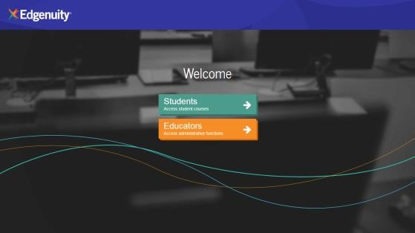
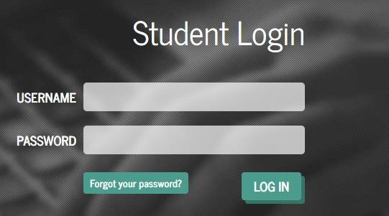
- Log in to https://learn.edgenuity.com and click the Students button. Or follow your teacher’s login instructions if they are different.

- On the login screen:
  - Enter the username and password provided to you by your teacher.
  - Click the Log In button.

Your Home Page
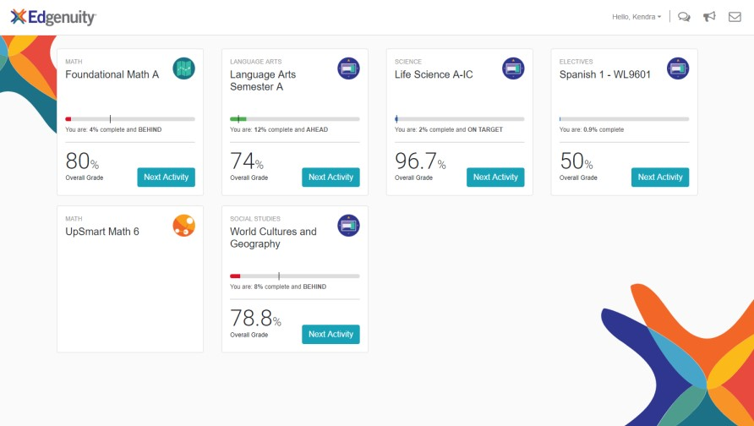
1.

Here you see a list of all
courses assigned to you,
along with your current
progress and course
grade.

2.

Click on the
title

of the
course to explore the
course map.

3.

Or, click any blue
Next
Activit
y

to begin working
immediately in the course.

A progress bar shows your current progress. It also displays target progress if a start and target date have been assigned to the course by your teacher. This progress bar is blue if you are on track, green if you are ahead, and red when you start to fall behind.
The course tiles will also show you the current grade in each of your courses.
The icons at the top of each tile indicate the type of Edgenuity program you are assigned:
Courseware MyPath UpSmart

Your Course Map
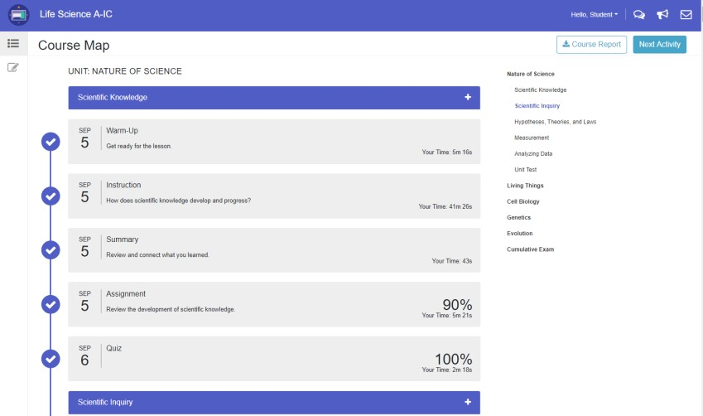
1.

From the
Home Page
,
click the
title

of the
course
that you would
like to
work on
.

2.

Here you see the
course map
displaying
all activities assigned to
you. The map auto
load
s

to the next
activity in the course,
and you can use the
course outline located
to the right to see what
has been assigned.

- Due dates appear next to each activity if your teacher has set a target date. This helps you stay on track by completing your daily assignments.
- Above the course outline is a downloadable Course Report that you can use as an assignment calendar and to track your progress and activity scores.
- Click a lesson title in the blue bar to view the lesson objectives, standards, and transcripts.
- When you complete your assigned coursework for the day, click the Courseware icon at the top left to navigate to another course or return to the Home Page.
By default, you are required to complete activities in the order in which they are assigned—unless your teacher has enabled Free Movement, you need to complete each activity in its entirety before moving on to the next activity.

Communication Tools
Often times a district, school, and teacher want to reach out with important information. Edgenuity also wants you to be able to reach out to your teacher and collaborate with others in your class. Let’s take a look at the three different ways this can be done.
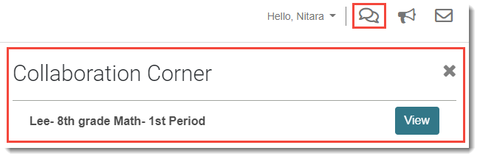
- Collaboration Corner: a discussion thread set up by an educator to allow you to interact in group discussions with other classmates.

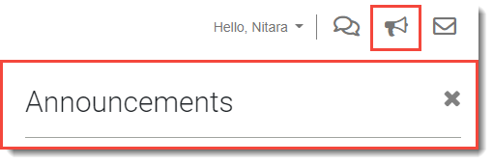
- Announcements: find information from your district or school.

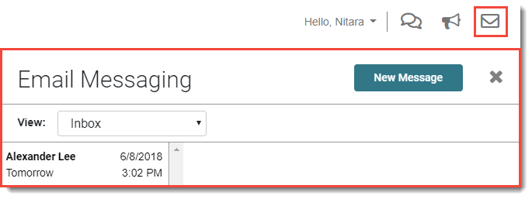
- Email: communicate directly with your teacher.

Courseware Learning Tools
Your online courses include a number of tools available to support your learning. You can take digital notes (eNotes), use the online glossary to view new vocabulary, and even read transcripts of the video instruction to ensure you don’t miss key information.
Many courses also have subject-specific tools available like calculators, formula sheets, and the periodic table. And if your teacher enables additional tools for you, you could have access to translate the text you see on screen into one of over 60 languages, or even have text read aloud to you. Let’s take a look at some examples.
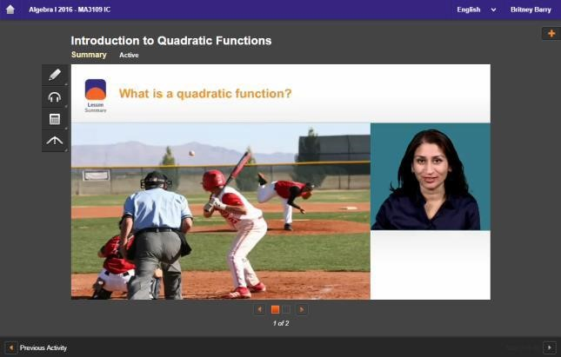
- Every lesson in your course gives you access to electronic notes (eNotes), an online glossary, video instruction transcripts, and a highlighter tool.
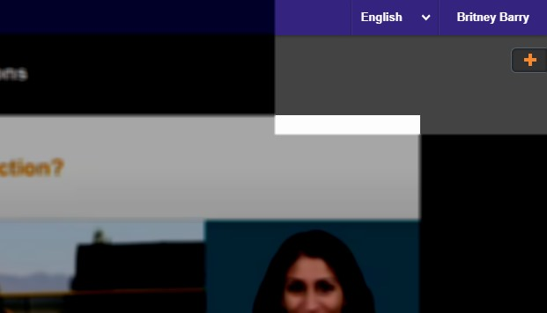
- Open these tools by clicking the orange plus sign at the top right corner, found under your name.
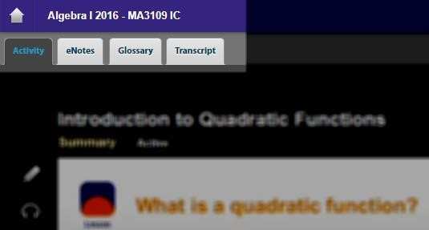
- Edgenuity automatically detects your screen size and adjusts to give you the best learning experience. On smaller screens, tablets, or mobile devices, you might find tabs across the top instead of the plus sign.
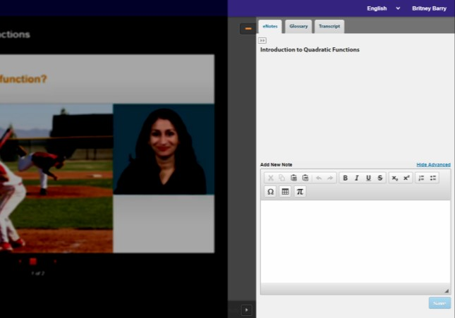
- Click on any tab to see the related information:
  - eNotes: take notes as you are learning; your teacher may allow you to access these notes during your assessments
Click these arrows under the eNotes tab to open and close the advanced view you see here. You’ll have access to additional formatting, an equation editor, as well as tables.
  - Glossary: access key vocabulary terms for your lesson and also look up unfamiliar words
  - Transcript: read the text of the video instruction
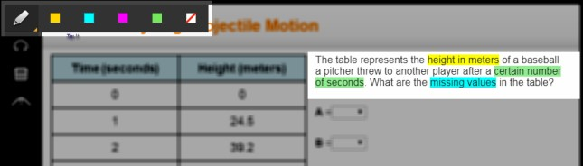
Highlighter: highlight text on the screen in various colors; these highlights do not disappear unless you choose to clear them; they will show up the next time you log into your course.

Learning Tools Enabled by Your Teacher
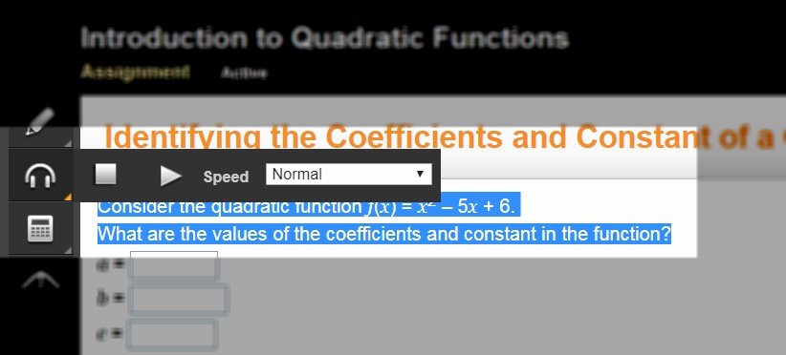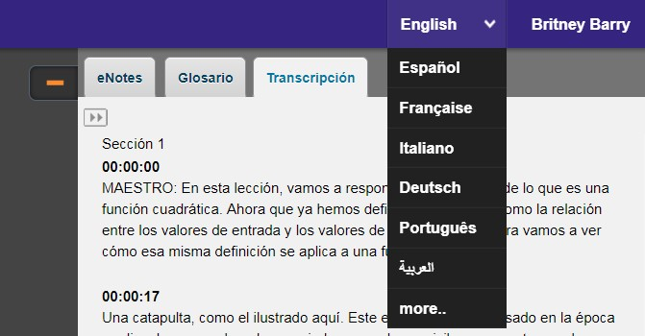
Read
-
Aloud
:
highlight the text on
screen and have it read aloud in
English; or any of the first 5
languages that appear in the
translation tool (see below). After
highlighting text, hover over the
read
-
aloud icon, then click play.

Translat
ion
:
translate any text on
screen into one of over 60 different
languages; opening the transcript tab
first allows you to translate the
transcript

into your
home
language
too!

Subject-Specific Tools
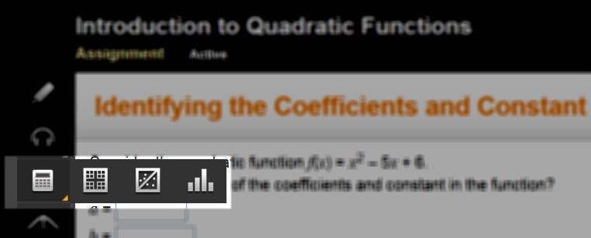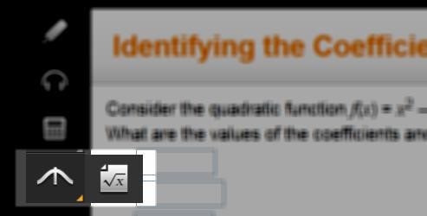
1.

Math Courses

•

Calculators
:
there are a number of
calculators available as needed,
including standard, graphing,
regression, and statistics
calculators; not all math courses
have calculators available.

•

Resources
:
you may need access
to helpful formula sheets or
additional resources which are
found at the
bottom of the
toolbar.

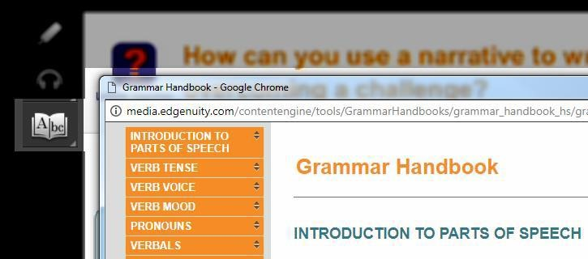
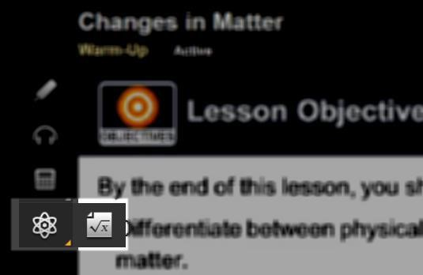
- English Language Arts Courses
  - Grammar Handbook: this is your comprehensive guide to all things grammar-related located at the bottom of the toolbar.
- Science Courses
  - Calculators: similar to Mathematics courses, you have access to calculators when they are required to complete your coursework.
  - Periodic Table: this tool may appear for some, but not all, science courses.

Student Reports
You have access to several reports that are helpful for staying on track to complete your coursework, view your progress, and monitor your own grades.
The Course Report also serves as an assignment calendar. Print this report and check off each of your assignments as you work through the course!
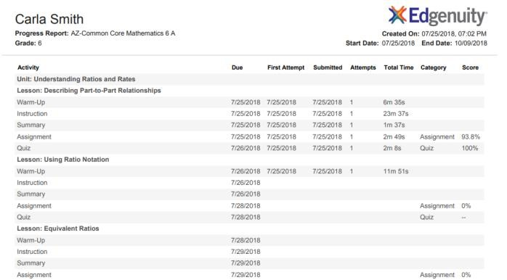
- Course Report: provides detailed information about all activities assigned to you within a selected course. Access the Course Report by clicking the button on the top right within the Course Map.

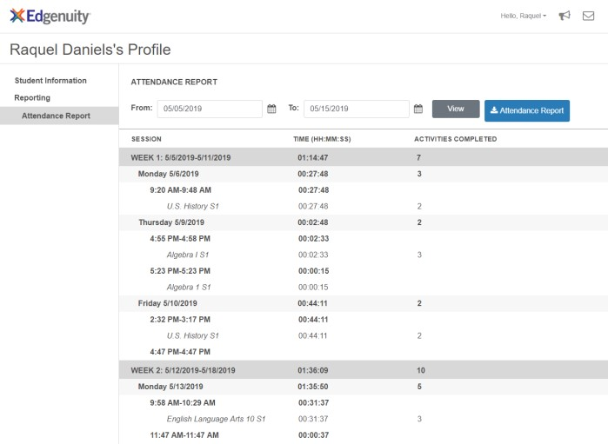
- Attendance Log: keep track of your daily activities through the attendance log, found on the Profile menu after clicking on your name in the top right corner.

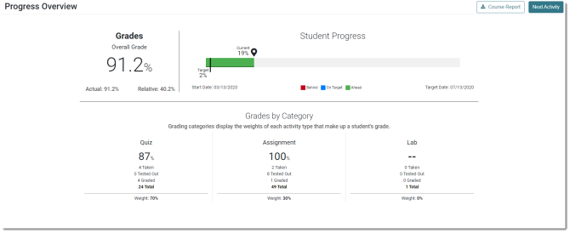
- Progress Overview: easily monitor your progress and grades within each course by visiting the Progress Overview report. This report is especially helpful to see how your course grade is calculated, how much work you’ve completed, and also how far along you are when your teacher assigns a target date for you.

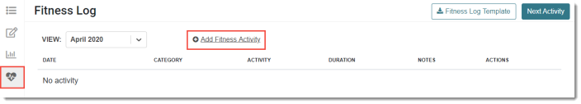
- Fitness Log: when enrolled in a fitness course, track your fitness activities- strength, cardio, and flexibility- into a log.

This icon will only appear for fitness-related courses.

